Antidiabetic drugs
Diabetes mellitus is a chronic metabolic disease characterized by hyperglycemia and impaired carbohydrate, lipid, and protein metabolism. This disease, which occurs as a result of impaired insulin secretion or its action on receptors, eventually causes chronic microvascular, macrovacuolar and neuropathic secondary diseases. Diabetes has become an important health problem worldwide because of its harmful effects on the patient's physical and psychological condition. There are two main types of diabetes, type 1 and type 2. Gestational diabetes, adult-onset diabetes, secondary diabetes caused by disease, and diabetes caused by medication are also known.
According to the American Diabetes Association (ADA), 4 criteria are used to diagnose diabetes.
1) The patient drinks a lot of water (Polydipsia), urinates a lot (Polyuria), eats a lot (Polyphagia), weight loss and typical indicators of hyperglycemia (arbitrarily measured blood glucose level more than 200 mg/dL)
2) Glucose level in fasting blood is 126 mg/dL and more
3) Sugar loading test, i.e. glucose tolerance test (blood sugar two hours after taking a concentrated glucose solution) 200 mg/dL or more
4) protein content HbA1c 6.5% and higher
According to the ADA, a fasting blood glucose level is between 100 and 125 mg/dL (known as impaired fasting glucose) and a blood glucose level measured 2 hours after an oral glucose tolerance test is between 140 and 199 mg/dL (impaired glucose tolerance) or patients with an HbA1c level of 6.5% or more are classified as prediabetics (patients with a high risk of developing diabetes).
Hemostasis of glucose, the main source of cellular energy, is regulated in the body by hormones such as insulin and glucagon. A plasma glucose level of 70-104 mg/dL is considered normal (standard). When the level of glucose in the blood increases, insulin is secreted by β-cells of the pancreas. Insulin reduces the level of glucose in the blood by inhibiting the production of glucose in the liver (glucogenolysis and gluconeogenesis) or by increasing the accumulation of glucose in the liver, muscles and adipose tissue. Glucagon is secreted by α-cells of the pancreas in response to a low level of glucose in the blood. Mainly in the liver, it increases glucogenolysis and gluconeogenesis, acting antagonistically on insulin, which leads to an increase in the production of glucose in the liver. Cortisol (hydrocortisone) and catecholamines also raise the level of glucose in the blood like glucagon.
Hormones, such as factor, glucagon-like peptide-1 (ГПП-1) and glucose-dependent insulinotropic polypeptide (GIP), play a role in the regulation of glucose hemostasis in the body. GLP and GIP are peptides secreted by the intestine and known as incretin hormones, which reduce the gastric emptying factor secreted by β-cells of the pancreas, along with insulin, and increase the absorption of glucose after eating. These hormones increase insulin secretion by β-cells after eating food.
Glucose, the main nutrient, is absorbed from the intestines with the help of glucose transporters. Glucose transporters are membrane glycoproteins, which are divided into sodium-dependent glucose transporters (SGLT) and facilitating glucose transporters (GLUT). Consisting of 664 amino acids, SGLT-1 is located in the cells of the small intestine and transports glucose based on the difference in concentration. SGLT-2 is located in the kidneys and ensures the reabsorption of glucose in the glomerular filtrate. Six SGLTs are present in liver, lung, heart and brain tissues. Unlike SGLT, the GLUT group acts independently of sodium. 12 GLUTs were found in mammalian cells (GLUT1-12). GLUT1, GLUT3 and GLUT4 are specific for D-glucose, while GLUT2 and GLUT5 are specific for D-fructose. Among the GLUT proteins discovered to date, GLUT4 is the most common protein found in adipose tissue and muscle tissue (heart, muscle and striated) and plays a role in insulin-mediated glucose transport. GLUT4 is the only insulin-sensitive glucose transporter protein found to date.
Pathogenesis of diabetes
Type 1 diabetes (juvenile diabetes, childhood diabetes)
Type 1 diabetes: this type of diabetes occurs in 5-10% of patients with diabetes and is considered an autoimmune disease. Type 1 diabetes is caused by genetic factors and many external factors that are not yet fully understood. Symptoms include drinking too much water (polydipsia), frequent urination (polyuria), excessive food consumption (polyphagia), weight loss, fatigue, and diabetic ketoacidosis. In type 1 diabetes, the pancreas is unable to produce insulin, as the insulin-secreting β-cells of the pancreas are immunologically (with antibodies) deformed. Thus, external insulin administration is the main condition for type 1 diabetes patients. Therefore, type 1 diabetes is also called insulin-dependent diabetes.
Type 2 diabetes
90-95% of patients diagnosed with diabetes mellitus are adults, the disease, as a rule, is associated with reduced physical activity, heredity and other factors. Its pathogenesis is mixed: it is characterized by both insulin resistance and decreased insulin secretion. Patients with type 2 can maintain a stable level of glucose in the blood simply by exercising and following a diet. Pharmacotherapy is started when the level of glucose in the blood cannot be normalized by diet and physical exercises. Many pharmacotherapeutic agents have been used for many years. Patients with type 2 diabetes mellitus, the etiology of which is not fully known, do not need external insulin supplements during life and, at least, when the disease develops again, therefore, type 2 diabetes is called non-insulin-dependent diabetes.
Diabetes during pregnancy
Gestational diabetes is diabetes that occurs during pregnancy, that is, the type of diabetes observed in women at risk of obesity and hereditary diabetes, who had an overweight child during a previous pregnancy. Often it passes by itself after birth. But in this group of people, the risk of developing diabetes 10 years after birth is very high.
Juvenile diabetes mellitus
Juvenile diabetes: A disease that leads to a decrease in insulin secretion as a result of genetic defects in the function of β-cells. This is an autosomal dominant hereditary disease that occurs in people with normal weight. In this disease, in which a decrease in insulin secretion develops, a decrease in the sensitivity of cells to insulin is not observed. Autoantibody tests are negative. This disease is distinguished from type 1 diabetes with the help of autoantibody tests.
Some biochemical parameters used in the diagnosis of diabetes
When assessing the diabetic state, they determine the amount of glucose in the blood, glycosidized hemoglobin (HbA1c), triglycerides, cholesterol, urea, creatine and ketones. HbA1c is formed as a result of non-enzymatic conjugation of the amino acid valine at the amino end of hemoglobin with glucose and is the only protein measured in blood for glycemic control. According to the American Diabetes Association, the level of HbA1c should be within 5-6%. A high concentration of this protein in the blood of patients with diabetes indicates poor control of the disease.
In recent years, the daily amount of C-peptide was also taken as a key parameter. The type of diabetes is determined by the level of C-peptide. Insulin is produced in the pancreas in combination with C-peptide (Connecting peptide) (in the form of proinsulin). After proinsulin is transported in the endoplasmic reticulum to the corpus callosum, it turns into insulin, losing C-peptide under the action of protease. When insulin is secreted by parietal exocytosis, an equimolar amount of C-peptide is also secreted. Therefore, the presence of C-peptide in the blood indicates that the pancreas produces insulin. C-peptide levels are low in patients with type 1 and high in patients with type 2.
Since the main causes of diabetes are obesity and a sedentary lifestyle, the main approach to the treatment of the disease is changing the lifestyle. Despite the fact that insulin is effective in the treatment of diabetes, its polypeptide structure does not allow it to be used orally. Synthetic drugs used in the treatment of diabetes are taken orally and are called antidiabetic drugs. Chemically, they are divided into two groups: derivative sulfonylacids and biguanidines. In recent years, the mechanisms of action of these drugs have been clarified and these drugs have been grouped by mechanism of action. According to the mechanism of action, oral antidiabetic drugs are divided into the following groups.
1) Substances that increase insulin secretion (Insulinotropic substances: derivatives of sulfanilside ore, analogues of meglitinides)
2) Substances that increase insulin sensitivity (metformin, thiazolidinedione derivatives)
3) Enzyme inhibitors
4) Incretin-based treatment group (agonists of glucagon-like peptide-1 (agonists of GPP-1) and inhibitors of dipeptidyl peptidase-4 (inhibitors of DPP-4))
5) Other groups of connections
When searching for new effective antidiabetic drugs, they considered not only the reduction of blood sugar, but also such pathological conditions as neuropathy, retinopathy, and cataracts that occur after diabetes.
Type 1 diabetes and gestational diabetes are treated with insulin. In patients with type 2 diabetes, if the amount of glucose in the plasma cannot be controlled with the help of diet and lifestyle changes, oral hypoglycemic drugs are used in pharmacotherapy. At the first stage, oral metformin is used, then oral derivatives of sulfonamides. In the second stage, dipeptidyl peptidase-4 (DPP-4) and thiazolidinedione derivatives are used. As the disease progresses, injectable analogues of GPP-1 are used for glycemic control, and insulin for strict control at the final stage.
Oral antidiabetic agents
Substances that increase insulin secretion (insulinotropic effect)
Production of sulfonic acid ore
In 1930, it was discovered that sulfanilamides, used for chemotherapy, cause hypoglycemia. On the basis of these results, work was started on the synthesis of antidiabetic drugs in the sulfanilamide structure. The drug, synthesized in 1954, was included in the treatment. Antidiabetic compounds included in the first course of treatment had a p-substituted benzenesulfonyl acid structure.
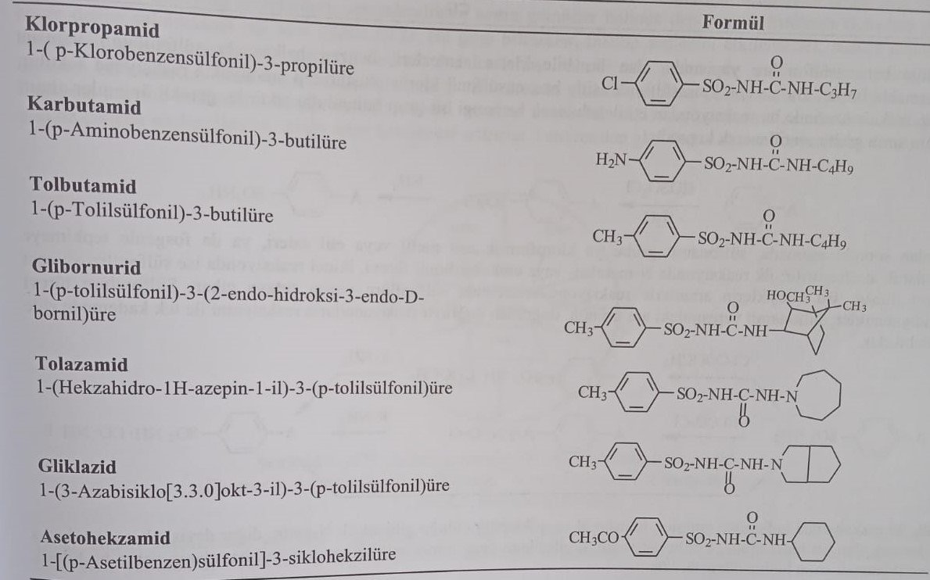
The second generation compounds synthesized in 1970 were in the structure of p-(2-carboxamidoethyl)benzene sulfonyl acid, and the amino group in the structure formed amide or imide.
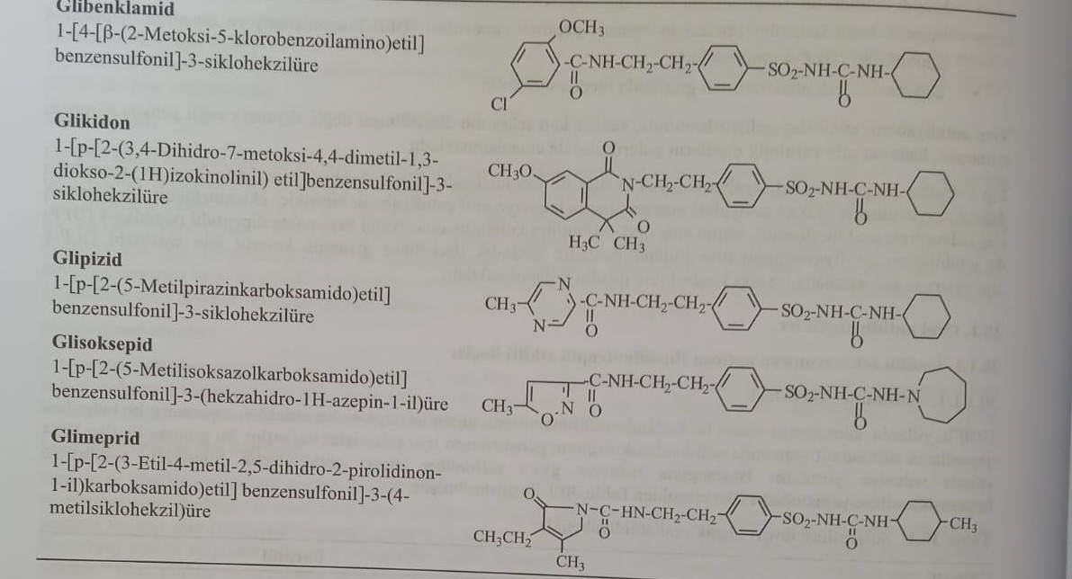
The syntheses of these compounds in the benzene sulfonylacid structure are based on the formation of a sulfonylamide structure in the benzene ring. For this purpose, with the help of chlorosulfonic acid, benzenesulfonyl chloride is formed and reacted with ammonia. If there is a functional group in the benzene ring that can enter into this reaction, measures are taken against it. For example, if there is an amino group, this group is acetylated and connected.
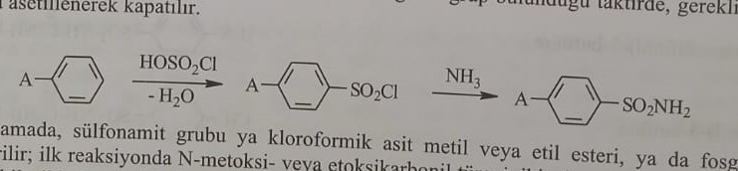
At the next stage, the sulfonamide group is activated either by its interaction with the methyl or ethyl ester of chlorformic acid, or with phosgene. In the first reaction, N-methoxy or ethoxycarbonyl derivatives are obtained, and in the second reaction, sulfonylisothiocyanate derivatives are obtained. As a result of the introduction of these compounds in the reaction with amines, the structure of sulfonyl acid appears. Sulfonylacid antidiabetic drugs are obtained by direct interaction of the intermediate compound of the sulfonamide structure with isocyanate.
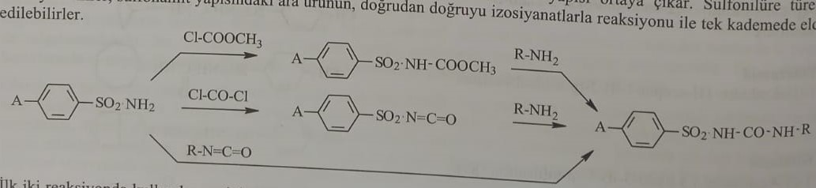
If the amines used in the first two reactions are cyclic N-amines, such as tolazamide and gliclazide, in other words, hydrazite with a nitrogen atom in the ring, then the nitroso derivative is obtained with nitric acid before the nitrogen-containing heterocyclic compound, which is then reduced to amines.
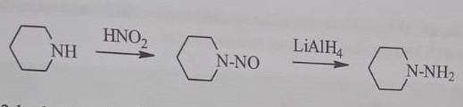
For the synthesis of compounds of the second generation containing the p-(2-carboxamidoethyl) group obtained in recent years, N-acetylphenylethylamine is first converted into sulfonamide, after hydrolysis of the acetyl group R-COCl, (R-CO)2O, R-CO-O- COOCH3 reacts with the formation of an amide or imide group.
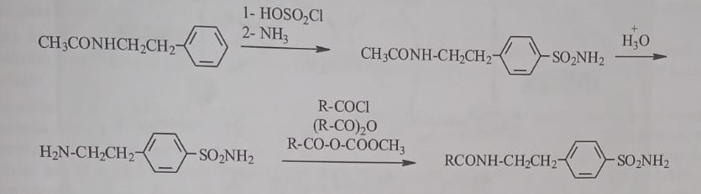
The mixture used in the reaction is obtained from the reaction of acid anhydride with methylchloroformate.
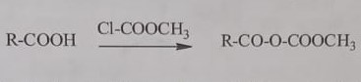
Despite the long-term use of sulfonylurea derivatives, the mechanism of action on β-cells was discovered in recent years. Thus, in the membrane of β-cells there are specific receptors that are sensitive to sulfonylic acid derivatives. Adenosine triphosphate (ATP)-sensitive potassium (KATP) channels are blocked due to the binding of antidiabetic drugs containing sulfonylurea derivatives to receptors (SUR1) located on the surface of β-cells of the pancreas. Thus, potassium channels that cause hyperpolarization in cells are closed. The inability of potassium to leave the cell leads to the fact that the intracellular electric potential becomes more positive than the extracellular one, which causes depolarization. This depolarization causes the opening of potential-dependent calcium channels and the release of calcium ions into the cell due to insulin exocytosis. This group of compounds does not affect the synthesis of insulin, they only increase the release of the stored hormone into the blood. Therefore, if the distortion of β-cells and insulin synthesis does not take place for some other reason, these drugs cannot show their pharmacological action. Long-term use of these drugs increases the sensitivity of β-cells to glucose stimulation. In addition to the effect on the cells of the pancreas, they also strengthen the action of insulin on the target cells. They reduce the output of glucose from the liver, inhibit lipolysis and enhance ketogenesis. They also reduce the secretion of glucagon by the pancreas.
Image: SUR receptors
The channel KATF, located in β-cells of the pancreas, is formed by a combination of four Kir6.2 proteins and four SUR1 subunits located around these proteins. The Kir6.2 protein organizes the transport of K+ ions, and the SUR1 subunit participates in the regulation of channel activity. Derivatives of sulfanilacida bind to the SUR1 subunit (receptor of sulfanilacida) of this channel and cause its closure.
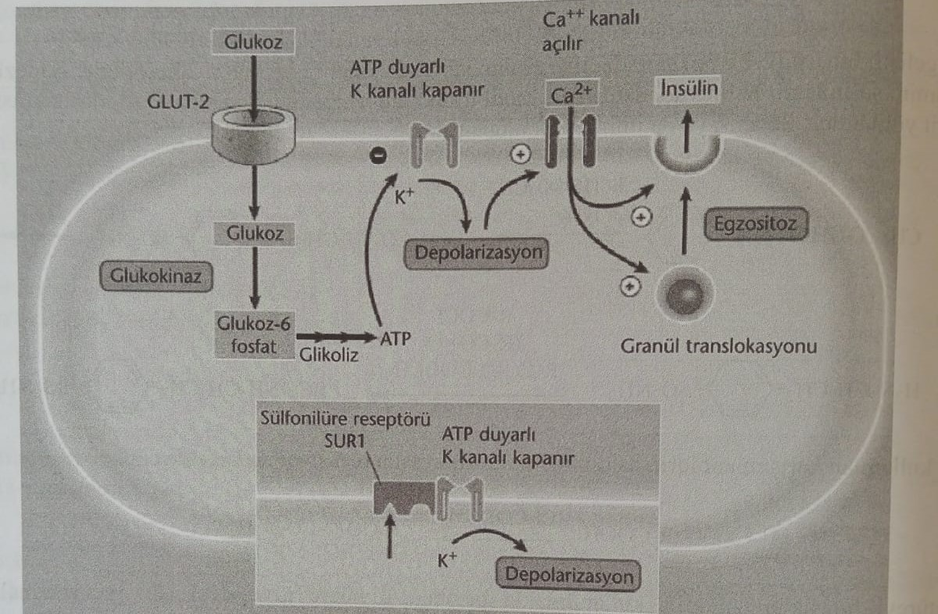
(ATF)-sensitive potassium (KATF) channels are located in the blood (SUR2B) and heart (SUR2A) in addition to the plasma membrane (SUR1) of β-cells of the pancreas. Sulfonamide derivatives bind to SUR receptors in the heart and blood vessels, such as SUR1 receptors, causing additional physiological effects. Binding to SUR2A in the heart blocks the opening of these channels, preventing calcium from entering the heart. As a result, death of myocardial cells occurs. In veins, SUR2B inhibition increases the tone of blood vessels and weakens blood flow to the supplied tissue. These effects lead to ischemia. As a result of the conducted studies, it was established that anionic groups (about 5) in the structure of derivative sulfonic acid ores play a key role in interaction with three subtypes of receptors. It was found that lipophilic groups (such as cyclohexyl, azepinyl, butyl, propyl) on nitrogen (N3) without a sulfonyl bond of the urea group provide selectivity for the SUR1 receptor. At the same time, it was found that the β-(carboxamidoethyl) group in the derivatives, known as second-generation sulfonyl acids, increases binding avidity in addition to providing selectivity for SUR1 receptors.
Derivatives of sulfanilside ore are used as antidiabetic, sugar-lowering agents in type 2 diabetes. It is mainly used by adults. They are the drugs of choice for diabetes that cannot be controlled by diet. From these compounds, tolbutamide is quickly absorbed and exerts its effect after oral administration. It lowers the blood sugar level to a minimum within 5-8 hours. However, it undergoes rapid metabolic inactivation. In chlorpropamide, inactivation occurs more slowly: for this reason, the activity and duration of action are long (up to 60 hours). In terms of effectiveness, tolazamide and acetohexamide occupy an intermediate position between tolbutamide and chlorpropamide. Glibornurid is a short-acting drug, but approximately 40 times more active than tolbutamide. The duration of action of drugs of the second generation is quite long. For example: the duration of action of glipizide and glyburide is 12-24 hours. Sodium salt in tolbutamide is used intravenously to check the function of the pancreas in the diagnosis of diabetes.
Transient hyperinsulinemia is observed after some time after reception. The risk of cardiovascular diseases, for example: the risk of myocardial infarction, is very high after the use of sulphonylurea derivatives. At the same time, they observe anorexia, nausea, vomiting, diarrhea, etc. Gastrointestinal disorders. Chlorpropamide increases the secretion of vasopressin and the sensitivity of renal tubules to this hormone, causing water retention and hyponatremia. Liver toxicosis, jaundice, leukopenia, granulocytosis, aplastic anemia can be observed after taking chlorpropamide. Prolonged use causes hypothyroidism.
The main structure in these compounds is the benzenesulfonyl acid ore structure, which contains subgroups in the para-position. The structure-activity relationship is as follows.
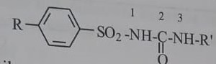
1) The activity increases if there are methyl, amine, acetyl, chlorine, bromine, iodine, methylthio and trifluoromethyl groups in the ring. The π-(2-carboxamidoethyl) group, found in second-generation drugs, also significantly increases activity compared to classical derivatives. It was found that in addition to providing selectivity for the SUR1 receptor, this group also increases the binding affinity of the molecule with the receptor. In these compounds, the distance between N1 in the sulfonic acid group and the nitrogen atom in the side chain is very important from the point of view of activity.
2) Groups on the ring play an important role in changing the duration of action of the molecule. If the compounds carrying the methyl group undergo rapid metabolic inactivation, then the molecules containing chlorine instead of methyl in their structure are more difficult to inactivate and have a long-term effect.
3) Groups located on N3 in the sulphanilacid group provide lipophilicity of the molecule. At the same time, compounds with a methyl group are inactive, with an ethyl group they are weakly active, and optimal activity is expected for 3-6 carbon radicals. But the addition of functional groups with the number of carbon atoms 12 or more to the molecule leads to the disappearance of activity. These functional groups can be aliphatic, cyclic and heterocyclic. The presence of aromatic groups increases toxicity. Some lipophilic groups attached to the N3 atom (such as cyclohexyl, azepinyl, butyl, propyl) provide selectivity for SUR1 receptors.
4) Despite the presence of a functional group attached to nitrogen N3 in currently used preparations, activity is observed in compounds with N3, N3-non-metal, when this nitrogen is an element of a heterocyclic ring.
5) In compounds using sulfonylsemicarbazida instead of sulfonylacid, т. е. The addition of the nitrogen group to N3 leads to a strong increase in activity.
6) Replacing oxygen with sulfur in the group of sulfonic acids seriously reduces activity.
7) Hypoglycemic activity is also observed in compounds containing sulfonamidooxadiazole, sulfonamidothiadiazole, sulfonamidopyrimidine instead of sulfanilsidic acid. Basically, these compounds carry sulfanylsemicarbazide, thiosemicarbazide or guanidine groups in the ring and form the structure –SO2-NH-C=, characteristic of active ingredients.
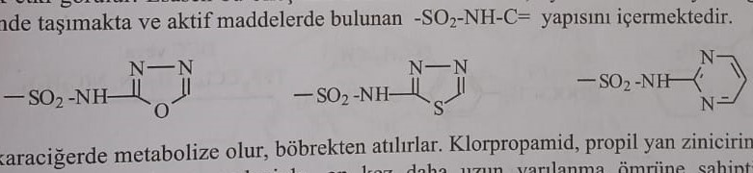
This group of compounds is mainly metabolized in the liver and removed from the body through the kidneys. Since the hydroxylation of the ω (omega) and ω1 positions in the propyl side chain of chlorpropamide occurs slowly, the half-life of this compound is 10 times greater than that of others. Tolbutamide and tolosamide are converted to alcohol (active metabolite) under the action of benzyl alcohol. оксидания и до хисти (inactive metabolite) пестом ее оксидния. At the same time, tolazamide turns into an active metabolite by hydroxylation of the fourth position of the hexahydroazepine ring, which leads to an increase in the duration of the drug's action. Acetohexamide turns into a metabolite of active alcohol by restoring the ketone group located on the phenyl ring. An inactive metabolite is formed as a result of hydroxylation of the cyclohexyl ring. Glyburide and glipizide are metabolized by hydroxylation of the cyclohexyl ring (4-trans- and 3-cis-hydroxy) and hydrolysis and subsequent acetylation of the amide group located on the phenyl ring. Glimeprid is metabolized by oxidation of the methyl group of the cyclohexyl ring to alcohol (an active metabolite), followed by an acid group.

Analog meglitinida (glinid)
As mentioned earlier, type 2 diabetes is a disease characterized by both insulin resistance and decreased insulin secretion. Conducted studies determined that a high level of sugar in the blood, both fasting and sated, is directly related to diabetes, in particular, long-term use of sulfonylurea derivatives causes hypoglycemia, so researchers developed short-acting, postprandial insulin secretion. This prevents hyperglycemia and, at the same time, the introduction of insulin between meals, which prompts the search for new means that increase insulin secretion and maintain their normal level.
Among the preparations of this group, for the first time, clay derivatives of benzoic acid (analogs of meglitinide) were discovered, which do not have a sulfonamide derivative, but stimulate insulin secretion (insulinotropic effect). Repaglinide and nateglinide are representatives in clinical practice that have received FDA approval, the prototype of which is Meglitinide. Similar to sulfonylurea derivatives, these drugs also bind to SUR1 receptors on β-cells of the pancreas. As a result, they inhibit ATP-sensitive K+-channels and provide insulin secretion. Although the mechanisms of action are similar to derivatives of sulfanilacide, they differ from derivatives of sulfanilacide in that their effects begin quickly and have a short duration of action.
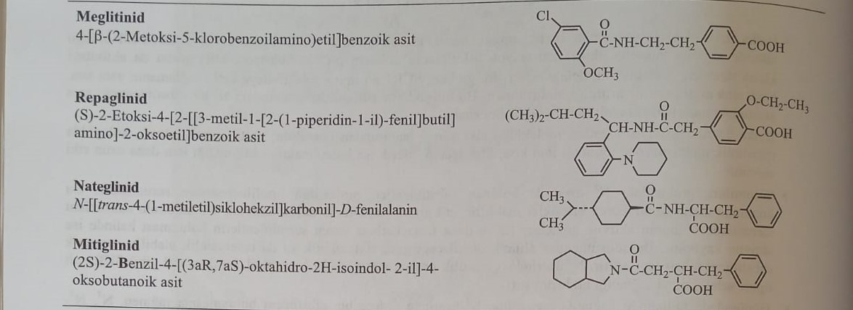
Repaglinide is a meglitinide derivative with a benzoic acid structure. The compound obtained by the reaction of (S)-3-methyl-1-[2-(1-piperidyl)phenyl]butylamine with ethyl ether of 2-[4-(ethoxycarbonyl)-3-ethoxyphenyl]acetic acid in the presence of dicyclohexyl carbodiimide or triphenylphosphine is synthesized Hydrolysis of ethyl(S)-2-ethoxy-4-[2-[3-methyl-1[2-(1-piperidyl)phenyl]butyl]amino]-2-carbonylethylbenzoate sodium hydroxide in methanol medium.
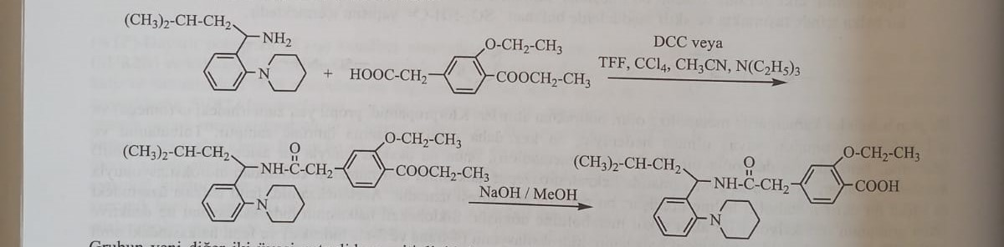
In addition to SUR1, the drug also binds to SUR1, SUR2A and SUR2B receptors located in cardiac and vascular muscles. For this reason, it also causes additional effects from the insulinotropic effect.
Two other new representatives of the group, nateglide and mitiglinide, are structurally different from the derivatives of benzoic acid, meglitinide and repaglinide, which appeared on the market later. Nateglinide, an analog of phenylalanine and an analog of meglitinide, selectively binds to SUR1 receptors on β-cells. It does not have an additional effect on the heart and blood vessels. The combination provides greater and faster insulin secretion compared to repaglinid. Hypoglycemia is not observed in patients, as the amount of insulin returns to normal in the state of fasting.
During the synthesis of nateglinida, trans-4-isopropylcyclohexanecarboxylic acid is formed by the restoration and epimerization of 4-isopropylbenzoic acid, which is formed during the oxidation of 4-isopropyltoluene. Chlorination of this compound with p-tosyl chloride in the medium of triethylamine with subsequent reaction with D-phenylalanine gives nateglinide.
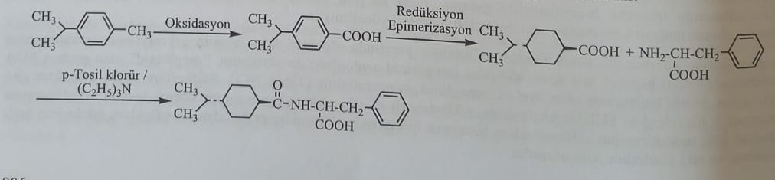
A compound similar in structure to nateglinide, mitiglinide, a derivative of succinic acid, is an analogue of meglitinide.
Although the side effects of this group of drugs are generally similar to other sulfonylurea derivatives, the possibility of weight gain and hypoglycemia attacks are less common. However, the disadvantage of these preparations is the necessity of frequent application (3 times a day) and a higher cost compared to derivatives of sulfanilsidnyh ores.
Relationship between structure and activity in compounds of derivative clay
1) Hypoglycemic clays also have an acid functional group, like sulfonylurea compounds. The acid functional group provides an insulinotropic effect. In these compounds, the acid group is a propionic or carboxyl group.
2) The acid group must be attached to the phenyl ring for activity.
3) Usually the acid group must be attached to the phenyl ring in the para-position.
4) Addition of a lipophilic group to an acidic functional group increases affinity and selectivity to SUR1 receptors. In derivatives of benzoic acid, such as repaglinide, this group contains a benzene ring instead of an acid functional group.
5) Nateglinide, a derivative of phenylalanine, has a chiral center adjacent to the carboxyl group. This center must be in the R configuration for activity in this group of connections.
6) Other derivatives of benzoic acid, such as meglitinide, also have a 2-carboxamidoethyl group, as well as second-generation sulfonylurea derivatives. In this group, the nitrogen of the amide functional group is often in the third position relative to the phenyl ring, and the carbonyl group is in the fourth position. However, high activity was observed in repaglinide, in which the carbonyl group is in the second position instead of the fourth. It was found that the carbonyl of the amide group is more important for activity than the nitrogen atom. This group acts by forming hydrogen bonds with SUR1 receptors.
7) The amide group in the nateglinide molecule is important for activity.
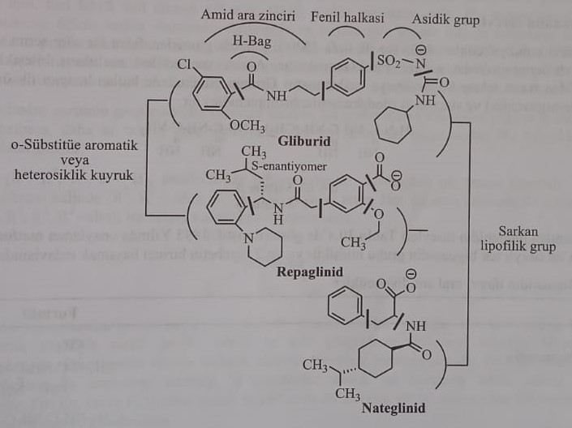
8) The intermediate chain of the amide is connected to the aromatic ring in the ortho-position in the repaglinide molecule, as well as in sulfonylic acid derivatives.

Repaglinide is metabolized to the first dicarboxylic acid by hydroxylation of the piperidine ring with the help of CYP2C8 and oxidative cleavage of the piperidine ring with the help of CYP3A4 with subsequent dealkylation to amines.
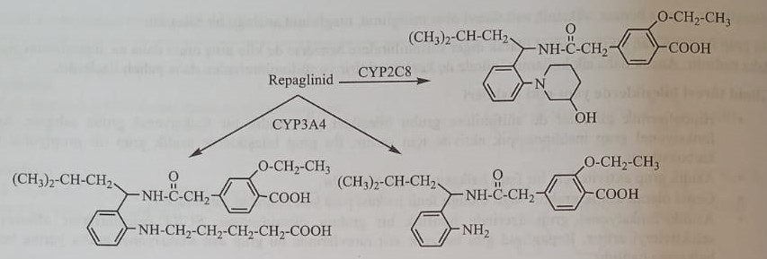
Nateglinide undergoes oxidative metabolism with the participation of CYP2C9 (70%) and CYP3A4 (30%). Hydroxylation occurs on the i-propyl group in the cyclohexyl group. The secondary analog of isoprene is an active metabolite with approximately the same antidiabetic activity as nateglinide. At the same time, this metabolite is subjected to glucuronidation by the carboxyl group.
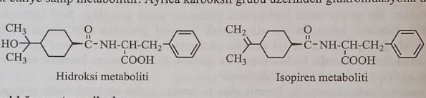
Drugs that increase sensitivity to insulin
This group includes two subgroups, such as derivatives of biguanidine and thiazolidinedione. Biguanides increase insulin sensitivity in the liver, and thiazolidinediones increase insulin sensitivity in adipose tissue.
Biguanidine derivatives
Antidiabetic drugs, derivatives of biguanidine, were first used in treatment in 1920. However, the hepatotoxic effect of these preparations already after the first application limited their use. However, after the discovery of drugs with reduced side effects, it was resumed in 1957. Sintalin A (decamethylenebisbiguanidine) and synthalin B (dodecamethylenebisbiguanidine) are the first examples of the group, which are not currently used.
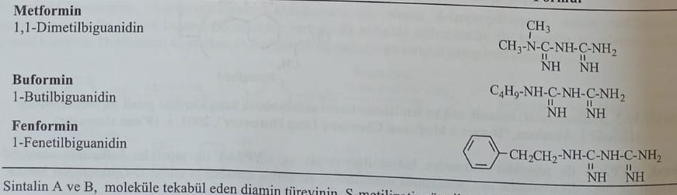
Biguanidine derivatives used in treatment are listed below. Metformin, approved in 1995, is currently the only biguanide derivative approved in the United States and included in the course of treatment for type 2 diabetes.
Metformin is obtained by the reaction of a diamine derivative, corresponding to the molecules of synthalin A and B, with S-methylisothiourea.
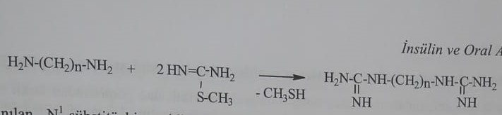
The syntheses of currently used N1-substituted biguanidine compounds are formed as a result of the reaction of an amine containing a semigroup with dicyandiamide.
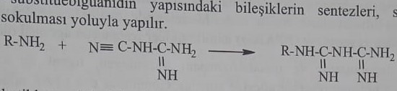
Antidiabetic agents obtained from biguanides show their effect by changing glucose metabolism. Does not affect the synthesis and secretion of insulin.
The mechanism of action is completely unknown, but it is believed that it is carried out by approximately 4 mechanisms.
1) Prevents the absorption of glucose, amino acids and other substances in the gastrointestinal tract.
2) They inhibit glycogenesis and glyconeogenesis in the liver.
3) They increase the peripheral anaerobic breakdown of glucose.
4) They increase the binding of insulin to the receptor in peripheral tissues and positively change the reaction of the receptor to insulin.
Antidiabetic agents derived from biguanidine show their effects only in the presence of insulin (type 2 diabetes). They do not cause hypoglycemia in normal people. Therefore, the use of the term "hypoglycemic" for these compounds is incorrect.
Buguanidine derivatives are used as antidiabetic sulfonylic acid derivatives in type 2 diabetes, when the disease cannot be controlled by diet. They can be included in the treatment in combination with derivatives of sulfonylic acid and derivatives of thiazolidinedione.
Metformin and buformin are partially absorbed from the gastrointestinal tract, the half-life is short (1.5-3 hours), they are removed from the body by the kidneys.
Since biguanidine derivatives strengthen oxidative mechanisms, they increase the amount of pyruvic acid and the product of its oxidation, lactic acid, which are formed as a result of the anaerobic breakdown of glucose. As a result of the decrease in gluconeogenesis, lactic acid is not included in the synthesis of glucose, and the amount of lactic acid in the blood increases. An increase in the amount of lactic acid causes metabolic acidosis. This condition is most often observed in phenformin. Phenformin and buformin were excluded from treatment, since they are more likely to cause metabolic acidosis, and this condition leads to a fatal outcome. In addition, these drugs cause cardiovascular diseases, diarrhea, renal and hepatic toxicosis.
The group responsible for antidiabetic activity is guanidine, and compounds containing this group have a highly toxic effect. Therefore, less toxic derivatives of biguanidine are being studied.
Relationship between structure and activity of derivatives of biguanidine
- Biguanidine (R1, R2, R3, R4=H) has an antidiabetic effect. The activity
increases when adding one or two subgroups to one of the nitrogen atoms (R1, R2=alkyl, R3, R4=H). The presence of a subgroup at both nitrogen atoms (R1,R2,R3,R4 = alkyl) leads to a decrease in activity and an increase in toxicity.
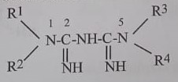
2) It is also known that the types of subgroups of N1 are effective in terms of activity. It was noticed that aliphatic subgroups up to six carbon atoms, especially methyl, propyl, pentyl and allyl groups, increase activity. When combining ten-carbon and large subgroups, the activity completely disappears. It was found that arylalkyl, for example, benzyl and phenethyl groups increase activity, but this also increases metabolic acidosis of lactic acid. Pyridine, furan and thiophene rings also increase activity, but compounds containing these groups are not synthesized because they increase toxicity more.
3) Subgroup N1-propyl-N5, N5-dimethylbiguanidine, attached to both nitrogen atoms, has an antidiabetic effect when administered parenterally, despite the results mentioned above. However, it is ineffective when used orally.
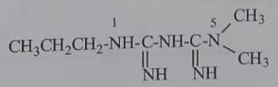
Derivatives of thiazolidinedione (glitazones, agonists of the receptor that activates the proliferation of peroxisomes (PPAR))
In 1997, tiroglitazone, an FDA-approved representative of thiazolidinedione derivatives, which differs from other groups of antidiabetic drugs in its chemical structure and mechanism of action, entered the market. It is believed that thiazolidinedione derivatives, the cellular mechanisms of which have not been fully elucidated, act by activating nuclear receptors, called peroxisome proliferation-activated receptors-γ (PPAR-γ), on insulin target cells.
PPARs are ligand-activated transcription factors that regulate the accumulation and metabolism of fatty acids and belong to the family of class II nuclear hormone receptors. PPAR-α, PPAR-β/δ and PPAR-γ group PPAR types are currently identified. PPAR-α mainly plays a role in the regulation of lipid metabolism (its activation reduces the level of triglycerides) and inflammatory processes. Activation of PPAR-β/δ increases the metabolism of fatty acids. PPAR-γ, localized mainly in adipose tissue, plays a key role in the regulation of glucose homeostasis and lipid metabolism. There are 2 isoforms of PPAR-γ receptors, PPAR-γ1 and PPAR-γ2. In addition to adipose tissue, PPAR-γ receptors are present in glucose-absorbing tissues, skeletal organs, and the liver. There are two isoforms in adipose tissue, but only the PPAR-γ2 receptor is present in the liver.
Thiazolidinedione derivatives used for the treatment of insulin resistance and type 2 diabetes: activate PPAR-γ receptors involved in the homeostasis of carbohydrates and lipids. Known natural agonists of these receptors in adipose tissue cells are free long-chain saturated and unsaturated fatty acids, which enter the cell by deposition from the blood. Activation of PPAR-γ, located in adipose tissue, plays a role in the transport, storage and oxidation of fatty acids. Thus, as a result of the expression of genes involved in this process, the supply of fatty acids increases and excess weight is formed. As a result of the increase in fat reserves, an increase in the amount of free fatty acids in the blood is observed. Therefore, the use of glitazone reduces the high levels of triglycerides and LDL, observed in patients with type 2 diabetes, and increases the levels of HDL.
Increased activity of PPAR-γ leads to a decrease in gluconeogenesis and glucose production in the liver.
PPAR-γ agonists simultaneously increase the expression of glucose transporter proteins in muscle cells and the sensitivity of muscle cells to insulin. Due to increased sensitivity to insulin, the consumption of glucose by muscles increases.
Thiazolidinedione derivatives increase insulin sensitivity and reduce insulin secretion by β-cells of the pancreas. Thus, these compounds prolong the life of β-cells. The protective effect on β-cells is proven by clinical and pharmacological studies. Derivatives of thiazolidinedione are agonists of PPAR-γ receptors and are also called glitazones. First-generation thiazolidinedione derivatives include pioglitazone, rosiglitazone, and ciglitazone.
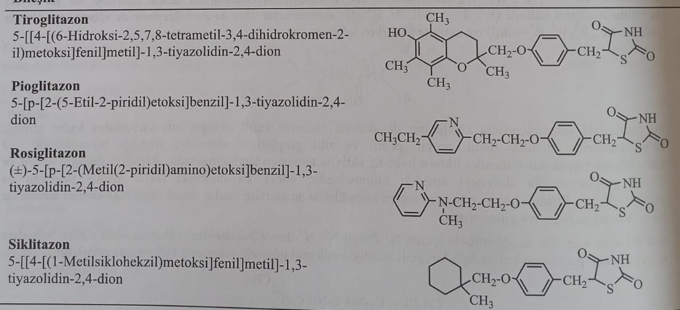
When creating compounds, they used thyroglitazone, which delays the oxidation of low-density lipoproteins and preserves the antioxidant structure of α-tocopherol. Later, tiroglitazone was withdrawn from sale due to severe hepatotoxicity. Serious side effects from the cardiovascular system were noted when using rosiglitazone, which are still being discussed. Due to side effects from the cardiovascular system, drugs containing the active ingredient rosiglitazone have been withdrawn from use in European countries since September 2010. It is still used in the USA and some countries. The only currently used representative of thiazolidinedione derivatives is pioglitazone.
Pioglitazone regulates insulin sensitivity, glycemic control, dyslipidemia, arterial hypertension and microalbuminuria in patients with diabetes mellitus. Since its effect is not proportional to the number of β-cells, it has been proven in many studies that it is a long-acting oral antidiabetic agent. It was found that pioglitazone causes edema due to water retention in the body. It belongs to the group of drugs with limited use in heart failure of the I-IV degree according to the New York classification due to water retention. The use of pioglitazone increases the risk of bone fractures due to disruption of bone homeostasis in osteoclasts (transition of calcium from bones to blood). Its use is contraindicated in liver failure, pregnancy, lactation, before surgery and infectious diseases.
Pioglitazone is synthesized using thiazolidine-2,4-dione, interaction of thiazolidine-2,4-dione with tert-butoxycarbonyl chloride or trityl chloride (triphenylchloromethane) and condensation of Knoevenagel with 4-hydroxybenzaldehyde, catalyzed by piperidine, in the medium of acetic acid with the protection of nitrogen group B position added 4-hydroxybenzylidene group Tert-butyl 5-(4-hydroxybenzyl)-2,4-dioxothiazolidine-3-carboxylate, formed by the interaction of the obtained condensation product with sodium borohydride in the medium of sodium hydroxide 2-(2-chloroethyl) Pioglitazone obtained by heating in hydrochloric acid followed by reaction with )-5-ethylpyridine.
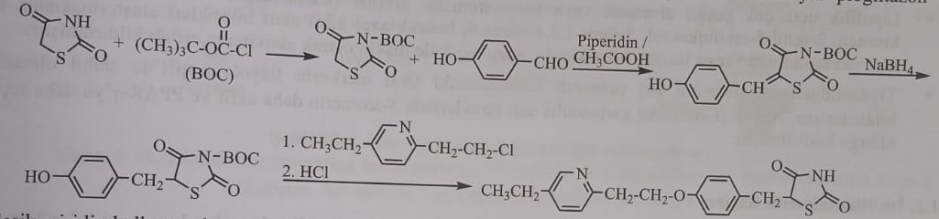
The compound turns into metabolites (М-1, М-2 и М-3), which play an important role in agonistic activity, by oxidizing benzyl on the methylene groups adjacent to the pyridine ring. At the same time, there are also metabolites formed during О-dealkylation (M-5) and ω-oxidation of the ethyl group of pyridine (M-4).
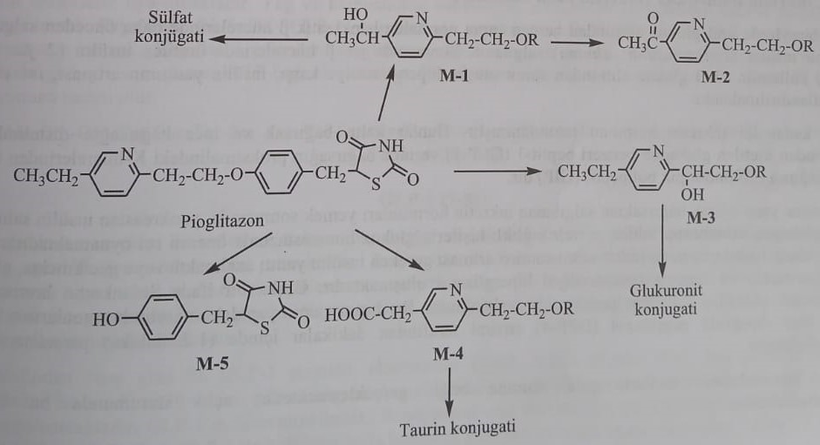
Structure-activity relationships of oral antidiabetics with thiazolidinedione derivatives
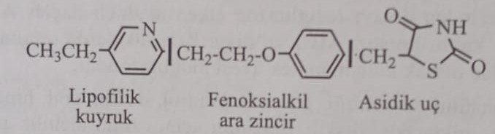
1) Oral antidiabetic preparations of thiazolidinedione derivatives are formed from a phenoxyalkyl intermediate chain connecting the acidic end with the lipophilic end. The pka value of compounds is about 6.8, so they are partially ionized at physiological pH. It was noted that this condition is important, and the activity is completely lost in N-methyl derivatives, in which the acid group is removed.
2) The group of pharmacophores, providing PPAR-γ agonist activity, is a thiazolidinedione ring. The ring system of thiazolidinedione is also active in oxazolidinedione and especially in derivatives in which groups in the alpha position are replaced by carboxylic acid. However, in these compounds, the selectivity against PPAR-γ is reduced.
3) A methylene bridge and a paraphenyl ring are attached to the main ring. It was established that this intermediate chain is necessary for activity, so that the activity of the saturated intermediate chain is higher than the activity of the unsaturated intermediate chain.
4) Central phenoxyethyl is important for activity. Activity is also observed in derivatives with a shorter chain or a phenoxyethyl group included in the heterocyclic ring.
5) At the lipophilic end, various aromatic or heteroatomic groups (cyclohexane, benzene, pyridine, chromene, 2-phenyl-5-methyloxazole, 5-phenyl-1,2,4-oxazole, benzoxazole) form active compounds.
6) It was established that the chiral center in the fifth position of the thiazolidinedione ring is unstable at physiological pH values. But it was established that the S-isomer of derived carboxylic acids in the α-position is more active and more selective in relation to PPAR-γ receptors.
Insulinomimetics preparations
This new group includes incretin mimetics, factor agonists, and some newly developed compounds. This group of compounds usually works by increasing the secretion of endogenous insulin.

Incretinomimetics (therapy on the basis of incretin)
In healthy people, immediately after oral intake of glucose, insulin is released, which was previously stored in β-cells of the pancreas (phase I of insulin secretion). Then the insulin synthesized in β-cells (II phase of insulin secretion) is used. Increased insulin response to hyperglycemia after oral glucose intake is called the incretin effect.
Today, two incretin hormones are identified. This is glucagon-like peptide-1 (ГПП-1), produced by L-cells in the distal part of the large and small intestine, and glucose-dependent insulinotropic polypeptide (GIP), produced by K-cells in the proximal part of the large intestine. small intestine.
Incretin hormones released by the intestine in response to food induce insulin secretion by the pancreas after eating, inhibit glucagon secretion, and play an important role in the regulation of glucose hemostasis in healthy people. However, in patients with type 2 diabetes, the insulin response, which should increase after taking carbohydrates, decreases or is delayed, and glucagon secretion, on the contrary, increases, which leads to hyperglycemia. In other words, the insulinotropic effect of incretin hormones is reduced in patients with type 2 diabetes. This is due to the fact that in these patients, the incretin hormone, which has a peptide structure, is split within a minute by the enzyme dipeptidase-4 (DPP-4), which belongs to the group of serine proteases.
The effects of incretin hormones are manifested depending on food intake, and this hormone is not secreted in the state of starvation.
Glucagon-like peptide-1 receptor agonists and dipeptylpeptidase-4 inhibitors in this group act either imitating incretin hormones or inhibiting incretin degradation. This group of compounds received the general name "incretinomimetics".
These two types of treatment show some differences in their clinical effects and methods of administration.
1) GLP-1 agonists: peptide structure and subcutaneous administration. DPP-4 inhibitor is taken orally.
2) GLP-1 agonists: increase the feeling of satiety due to slowing down of gastric emptying and, thus, have the effect of reducing weight. However, the effect of DPP-4 inhibitors on gastric emptying has not been reported.
This group of compounds does not cause hypoglycemia compared to derivatives of sulfonylurea, since they act in a glucose-dependent manner and reduce the level of glucose in the blood only on an empty stomach. At the same time, these drugs can cause hypoglycemia when used simultaneously with secretion stimulants (sulfanilacid derivatives, glinides) and insulin.
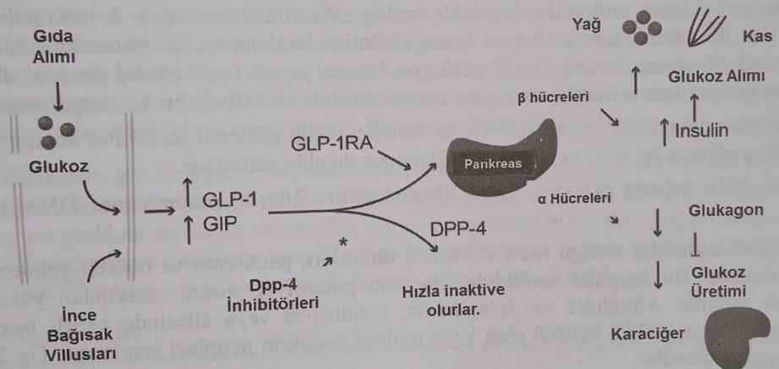
Agonists of glucagon-like peptide-1 (ГПП-1)
This group of compounds mimics the endogenous incretin hormone GLP-1. GLP-1 is produced by L-cells located in the intestinal epithelium and consists of 36 amino acids. Secretion of GLP-1 can be caused by food intake, nervous activity and various endocrine factors. A diet rich in fats and carbohydrates is the main physiological factor contributing to the secretion of GLP-1. Secretion of GLP-1 is analogous to glucose-dependent secretion of insulin by β-cells of the pancreas. Glucose metabolism in L-cells of the intestine causes membrane depolarization and movement of Ca2+ ions inside the cell. As a result, ATP-dependent potassium channels are closed and GPP-1 is secreted.
ГЛП-1 (7-36)
GLP-1 acts on specific GLP-1 receptors located in many organs, including the pancreas, central nervous system, heart, stomach, lungs and intestines. In the pancreas, GLP-1 increases insulin secretion and accumulation, causing membrane depolarization. Inhibiting the secretion of glucagon, stops the process of gluconeogenesis in the liver. N. Acting on the vagus nerve (Azan nerve), it reduces gastric emptying and reduces food consumption, increasing the feeling of satiety.
The first GLP-1 agonist approved by the FDA is exenatide (2005, USA). This compound, a synthetic derivative of exendin-4, a polypeptide of 39 amino acids, isolated from the saliva of one of the species of lizards, is administered parenterally. It is obtained by replacing the second amino acid, alanine, with glycine at the N-end of the GLP-1 molecule. The amino acid structure of this compound is more than 50% similar to GLP-1, and the half-life of this compound in vivo is approximately 3 hours. This drug, which is administered twice a day, is more effective in reducing hyperglycemia saturation. , more effective than other antidiabetic drugs and weight loss drugs unlike insulin. In the treatment of type 2 diabetes, if treatment with metformin and sulfonylurea derivatives does not work, treatment with these drugs is started.
It has been reported that exenatide causes acute pancreatitis in post-registration conditions. However, since acute pancreatitis is also observed in diabetes, the effect of this drug causing acute pancreatitis remains questionable. But at the request of the FDA, a warning about the risk of acute pancreatitis was written on the insert of the drug.
In 2010, liraglutide went on sale with FDA approval. The compound is obtained by adding α-glutamoyl-(N-α-hexadecanoyl) to lysine at position 26 of the GLP-1 amino acid sequence and replacing lysine at position 34 with arginine. The compound has the form α-glutamyl-(N-α-hexadecanoyl)-Lys26-Arg34-GLP-1. It has been shown that this compound, a long-acting glucagon-like peptide-1 (GPP-1) receptor agonist, induces insulin secretion by binding to the receptor to which the endogenous metabolic hormone GPP-1 binds.
Abiglutide is a compound obtained by fusing two molecules of GLP-1 with human albumin ([7-36]-glucagon-like peptide-1 [7-36]-glucagon-like peptide-1 [8-glycine] (human)- [7-36] ]-glucagon-like peptide-1-[8-glycine]-(human)-albumin (human)). This structural change increases the half-life of the compound by 5 days. The drug is used once a week.
As a binding protein, dulaglutide is obtained by covalently linking two GLP-1 analogs with 90% similarity to human GLP-1 with a modified IgG4Fc peptide chain.
The newest representative of the group is lixisenatid, which entered the market in 2016. The connection was obtained by recombinant DNA technology.
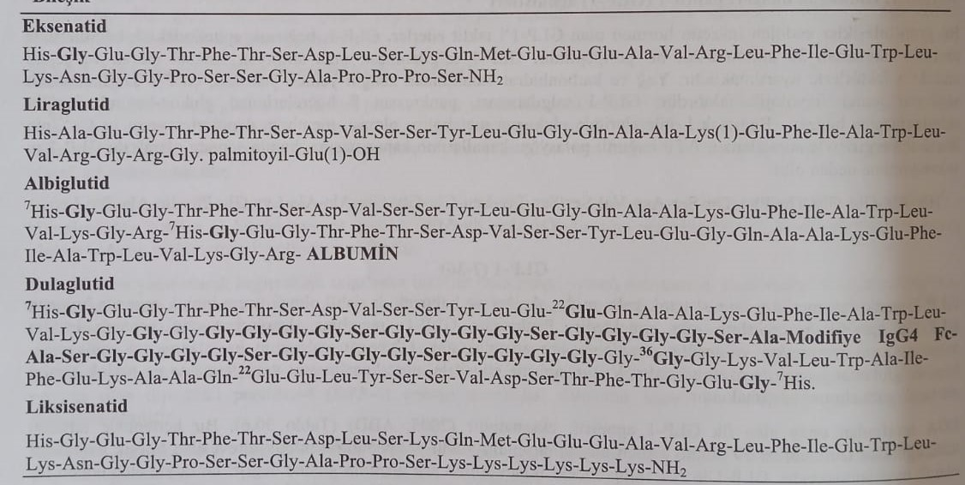
Liaglutide, albiglutide and dulaglutide have serious side effects, such as malignant tumors of the thyroid gland from C-cells, pancreatitis and kidney failure.
Dipeptidyl peptidase-4 (DPP-4) inhibitors (Gliptins)
As indicated above, incretin hormones are cleaved by the enzyme dipeptidyl peptidase-4 (DPP-4), which is an aminopeptidase in the structure of a serine protease located on the surface of endothelial and epithelial cells, in less than 1-2 minutes by cleaving 2 amino acids from the N-terminus (GLP- 1 cleaves the dipeptide His-Ala from the N-end of GLP-1, which leads to inactivation of GLP-1). DPP-4 enzyme is contained in the liver, lungs, kidneys, intestines, lymphatic tissues, as well as in the blood in a dissolved form.
Dipeptidyl peptidase-4 (DPP-4) inhibitors increase the endogenous amount of incretin hormones (ГПП-1 and ГИП) due to inhibition of the specified enzyme. As a result, the action and duration of action of incretin hormones increases. Since they do not have a peptide structure, these compounds are easily administered orally. Since 2006, these compounds have entered the pharmaceutical market.
When studying the general structure of DPP-4 inhibitors, it was established that the first inhibitors discovered were derivatives of α-aminoacylpyrrolidine as a result of the enzyme's proline craving. The most active DPP-4 inhibitors carry an electrophilic group in their structure in addition to the main amino group. The most widely used electrophilic cyano group is found in the chemical structure of vildagliptin, saxagliptin and alogliptin. It was found that the cyano group plays an important role in the reversibility of the serine amino acid (Ser630) in the active center of the enzyme.
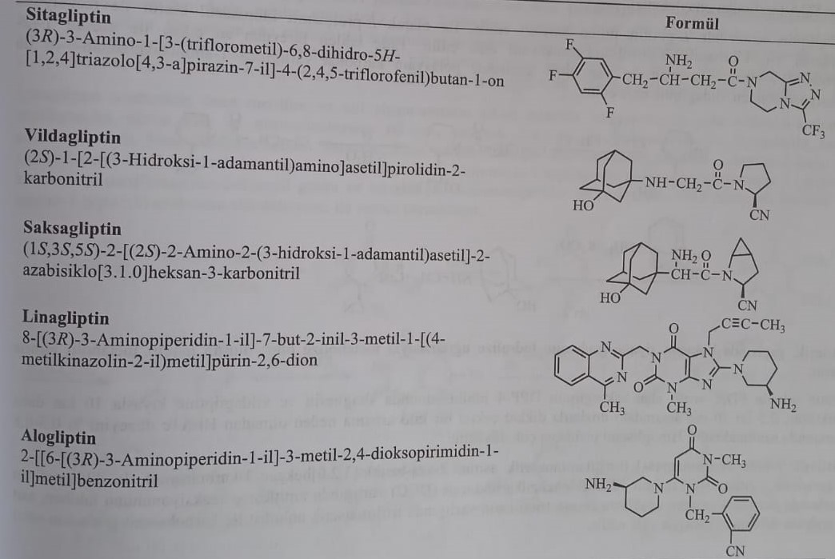
Sitagliptin is the first DPP-4 inhibitor with a β-amino acid structure approved by the FDA in 2006. The compound for oral administration is recommended for monotherapy and combined therapy with metformin, sulfonylurea derivatives or thiazolidinedione derivatives. Sitagliptin has been reported to cause pancreatitis.
The compound is obtained by the reaction of methyl 3-oxo-4-(2,4,5-trifluorophenyl)butanoate with (S)-2-amino-2-phenylacetamide followed by the reduction of the derivative enamine with platinum dioxide to sodium hydroxide and 3-(trifluoromethyl)- in the result of the reaction with 5,6,7,8-tetrahydro-1,2,4-triazolo[4,3-a]pyrazine.
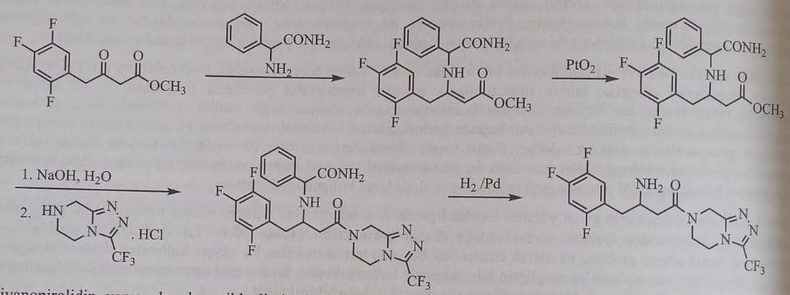
Vildagliptin, which has a cyanopyrrolide structure, was approved for use in the European Union by the European Medicines Agency (EMA) in 2008. The combination was also confirmed in Europe, Latin America, Asia and Japan. But it was not approved by the FDA.
L-prolinamide is used in the synthesis of vildagliptin. First, L-prolinamide reacts with chloroacetyl chloride to form 1-(2-chloroacetyl)-2-pyrrolidinecarboxamide. Vildagliptin is obtained as a result of the reaction of 1-(2-chloroacetyl)-2-pyrrolidinecarbonitrile with 1-aminoadamantan-3-ol in the presence of potassium carbonate in the presence of acetonitrile.
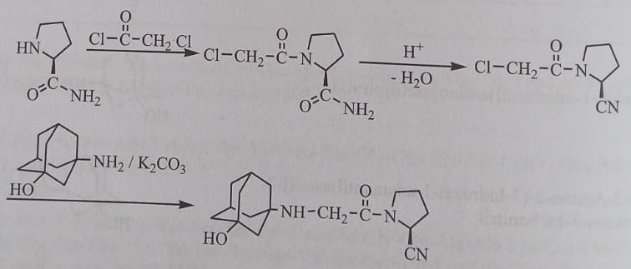
Cyanogroup in the structure of the compound is metabolized by hydrolysis. The inactive metabolite is excreted in the urine.
Saxagliptin, which received FDA approval in 2009, inhibits DPP-4 10 times more effectively than sitagliptin and vildagliptin. In doses of 2.5 and 10 mg, it reduces the amount of HbA1c by 0.5-0.8%, without causing a significant increase in body weight. The probability of occurrence of hypoglycemia is very low.
After the amidation reaction of saxagliptin with 3-hydroxyadamantan-1-yl-tritylaminoacetic acid with 2-aza-bicyclo[3.2.0]hexane-3-carboxamide in the presence of N-hydroxysuccinimide and dicyclohexylcarbodiimide in dichloromethane, the removal of the protective group in an acidic medium was performed using trifluoroacetic anhydride. in triethylamine, obtained by converting a carboxyl group to a nitrile group.
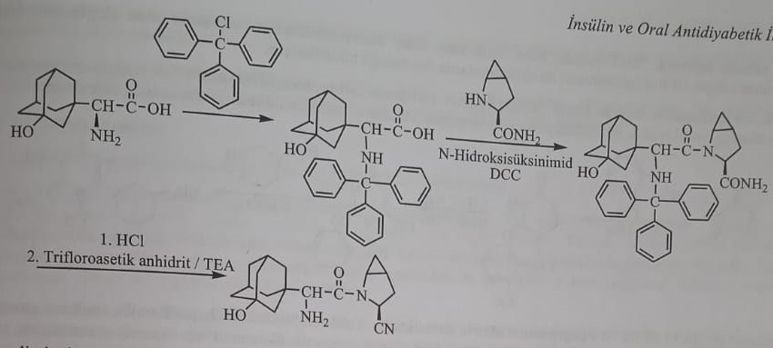
Saxagliptin is metabolized both in the kidneys and in the liver. Half of the absorbed dose is metabolized in the liver. The main metabolite is 5-hydroxysaxagliptin, which is formed by CYP3A4/5. The metabolite has half the activity of saxagliptin as an inhibitor of DPP-4.
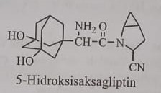
Linagliptin, a xanthine derivative, received FDA approval in 2011. The compound inhibits DPP-4 activity in plasma by more than 80% within 24 hours. It should not be used in patients with type 1 diabetes and diabetic ketoacidosis. The most important side effects are: upper respiratory tract infection, nasal congestion, runny nose, sore throat, muscle and headache. 90% of the compound is excreted unchanged in the urine.
In the synthesis of linagliptin, 6-amino-1-methyluracil, obtained by the reaction of ethylcyanoacetate with ethylcyanoacetate in an alkaline medium, is obtained by nitration with nitric acid followed by reduction with sodium dithionide and cyclization with formamide to form a 3-methylxanthine cycle. After bromination of this compound, 2-butyn-1-yl group in position 7 from reaction with 1-bromo-2-butynin, 4-methylquinazolin-2-yl methyl group in position 1 from reaction with 2-chloromethyl-4-methylquinazoline, and then it is synthesized by introducing a 3-amino-1-piperidyl group in position 8 from the reaction with (R)-3-aminopiperidine.
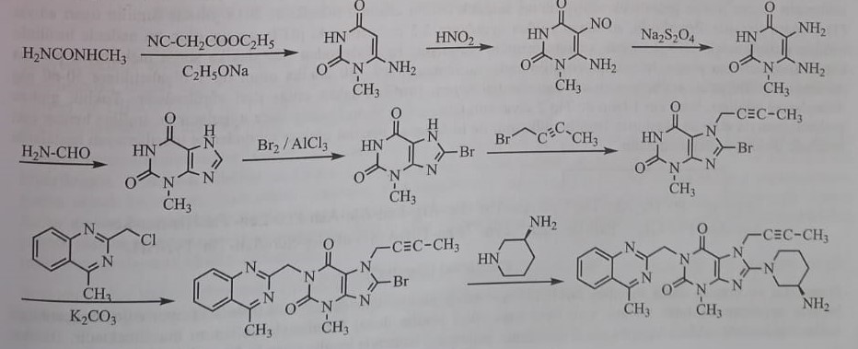
The pyrimidinedione formulation alogliptin, which received FDA approval in Japan in 2010 and 2013, was found to reduce HbA1c levels to the same extent as DPP-4 inhibitors.
The compound is obtained by methylation of the derivative obtained from the reaction of 6-chlorouracil with 2-(bromomethyl)benzonitrile in the presence of sodium hydride and lithium bromide with methyl iodide followed by reaction with 3R-aminopiperidine.
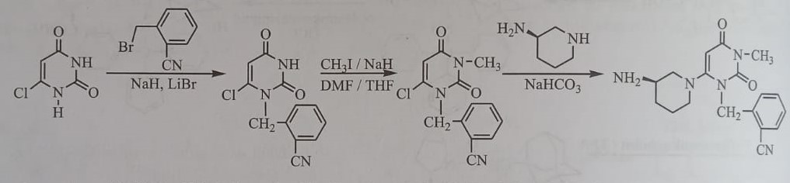
60-70% of the administered dose is excreted unchanged in the urine. Approximately 10-20% is metabolized in the liver with the participation of cytochrome enzymes CYP2D6 and CYP3A4. A very small amount of N-demethyl and N-acetyl metabolites were detected. The N-demethyl metabolite has the same inhibitory effect on DPP-4 as alogliptin.
amine agonists
Amylin, a single-chain peptide hormone containing 37 amino acids in its structure, is secreted together with insulin from β-cells of the pancreas. Amylin, like insulin, delays gastric emptying, regulates blood sugar level due to reduction of glucagon secretion and endogenous production of glucose in the liver (gluconeogenesis). At the same time, it acts on the appetite center of the brain and balances food intake. It was found that the factor with such effects and its agonists are able to regulate the level of glucose in the plasma. The lack of good solubility of amyl in solution limits its use as a medicine. For this reason, in medical practice, the factor itself is not used as a medicine, but its synthetic analogues.
Pramlintide
Pramlintide is a synthetic analogue of amyl, obtained by replacing amino acids Ala25, Ser28 and Ser29 with proline to prevent expected and spontaneous aggregation of amyl. In 2015, it received FDA approval under the name Simil. Pramlintide is administered subcutaneously. If the pH is higher than 5.5, it aggregates. It is used in doses of 30-60 mg for type 1 diabetes. It is used before meals in the treatment of type 1 and type 2 diabetes. If the disease cannot be treated, the drug can be used in combination with insulin. However, since the medicinal forms of pramlintide and insulin have different pH indicators, these two preparations cannot be mixed and used together in one syringe. To reduce the risk of severe hypoglycemia during combined treatment, it is necessary to reduce the dose of insulin by 50%.
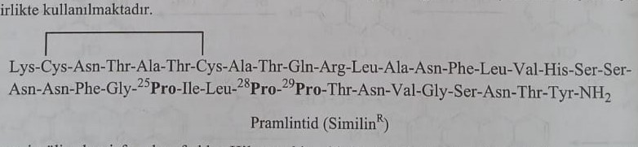
Inhibitors of sodium-glucose transporter protein type 2 (SGLT-2)
In healthy people, gluconeogenesis accounts for 50-60% of glucose production after night fasting. Gluconeogenesis occurs mainly in the liver and kidneys. In healthy people, 180 g of glucose passes into the glomerular filtrate daily, and most of it is reabsorbed from the proximal tubules. Only 0.5 g of glucose is excreted in the urine per day.
Glucose, a food substance, is absorbed from the intestines with the help of glucose transporters. Glucose transporters are membrane-bound glycoproteins. These transport proteins are called sodium-glucose transporters (SGLT) and glucose transporters (GLUT). SGLT-1 and SGLT-2, belonging to the SLC5A gene family, are the most studied sodium-dependent glucose transporters. SGLT-1 is mainly found in the small intestine, proximal tubules of the kidneys and the heart. This is a sodium-dependent glucose transporter with low transport capacity and high avidity. SGLT-2 is located in the proximal sections of the proximal tubule of the kidney (segments S1-S2). This is a glucose carrier protein with high transport capacity and low avidity.
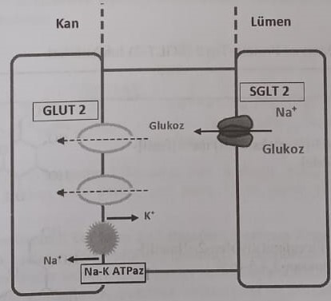
SGLT-2 transports glucose together with sodium ions into the epithelial cell due to active transport against the concentration gradient. Glucose in the epithelial cell is introduced into the intracellular space with the help of glucose transporters type 2 (GLUT2) and type 1 (GLUT1), located in the basolateral membrane, and by passive diffusion. The Na+ gradient for the epithelial cell is provided by the Na-K-ATPase located in the membrane.
Regulation of glucose homeostasis is provided by SGLT-1 and SGLT-2 due to the reabsorption of glucose from the kidneys. The greater presence of SGLT-2 and GLUT-2, which have a high glucose transport potential in the proximal parts of the proximal tubules, causes the reabsorption of most of the glucose in the glomerular filtrate. The remaining glucose is reabsorbed by means of SGLT-1, located in the distal part of the proximal tubules. But when there is a high level of glucose in the plasma, SGLT-2 proteins are saturated with glucose molecules, and the remaining glucose molecules are excreted in the urine.
SGLT-2 inhibitors prevent reabsorption of glucose by inhibiting SGLT-2 in the proximal tubules of the kidneys. As a result, glucosuria increases and the amount of glucose in the blood decreases.
In 1833, French chemists isolated phlorizin from the bark of apple roots for the treatment of malaria, fever and infectious diseases. In a 1975 study, it was found that the infusion of phlorizin in dogs increases the excretion of glucose by 60%. In this compound, which has the structure of β-D-glycoside, one molecule of glucose is attached to two phenyl rings connected by an alkyl intermediate chain.
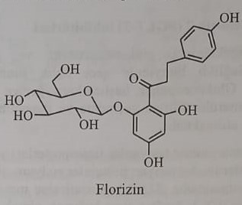
Phlorizin, which is hydrolyzed to glucose and phloretin by the glucosidase enzyme in the intestine, inhibits both SGLT-1 and SGLT-2 and has low bioavailability, limiting the use of the drug. In the following years, dapagliflozin, canagliflozin and empagliflozin, which are more selectivity and stability, tolerant to β-glucosidase enzyme, phlorizin analogues in C-glycoside structure, were synthesized.
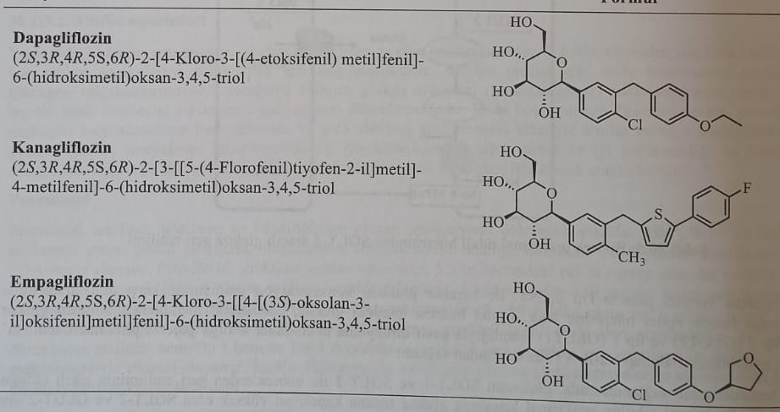
Dapagliflozin is a competitive, reversible and highly selective SGLT-2 inhibitor. Compared to phyllorizin, this drug inhibits SGLT-2 more than SGLT-1, 1200 times. The compound is synthesized using 2-chlorobenzaldehyde. After bromination, 2-chlorobenzaldehyde is restored and 5-bromo-2-chloro-4,-ethoxydiphenylmethane is obtained by the Friedel-Crafts alkylation reaction of 5-bromo-2-chlorobenzyl chloride with ethoxybenzene. 1-chlor-4-(1-chlor-4-(1-), obtained by the reaction of the obtained compound with butyllithium and 2,3,4,6-tetrakis-o-trimethylsilyl-D-gluconolactone in the medium of tetrahydrofuran followed by methanesulfonic acid. Demethylation of methoxy-D-glucopyranosyl)-2-(4-ethoxybenzyl)benzene with triethylsilane in methanol medium gives dapagliflozin.
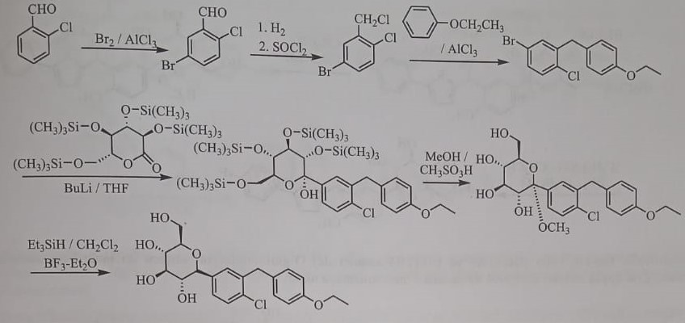
Since dapagliflozin is excreted by the kidneys and no active metabolite remains, it is used in a single daily dose. Since the cytochrome p450 system does not participate in the metabolism of dapagliflozin, it was established that the drug is mainly subjected to glucuronidation, hydroxylation and de-ethylation. 3-O-glucuronide, the glucuronide conjugate of the compound formed by UGT1A9, is the main metabolite.
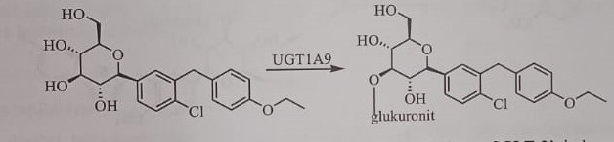
Canagliflozin received FDA approval in 2013 under the trade name Invokana. This is a competitive, reversible and selective inhibitor of SGLT-2, it is quickly absorbed after oral administration, the half-life is 15-16 hours. Suitable for single use.
The synthesis of canagliflozin is initiated by the Friedel-Crafts acylation reaction of 5-bromo-2-methylbenzoyl chloride and 2-(4-fluorophenyl)thiophene. The resulting 2-(5-bromo-2-methylbenzoyl)-5-(4-fluorophenyl)thiophene is reacted with sodium iodide and copper monoiodide in the presence of N,N-dimethylethylenediamine and iodine is added to position 5. After the ketone group is reduced in the presence of biohydride Sodium and protection of the formed alcohol with trimethylchlorosilane compound are subjected to interaction with gluconolactone, protected with trimethylsilyl, under the conditions of butyllithium catalysis and an oxane ring is introduced into the structure. After removal of silyl groups with methanol in the presence of metasulfonic acid, canagliflozin is synthesized by demethylation in the presence of triethylsilane and boron trifluoride.
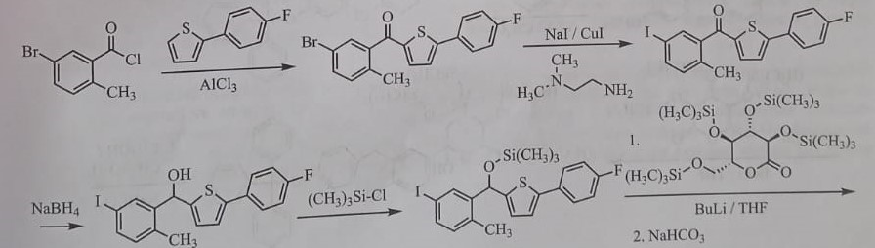
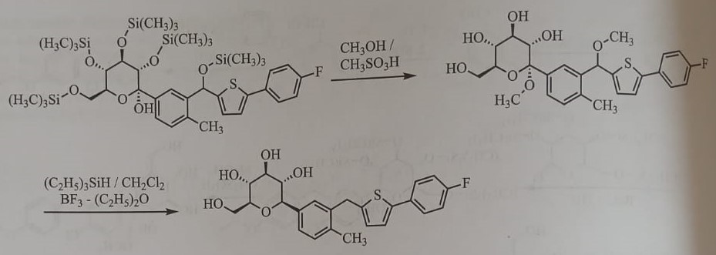
Canagliflozin is converted to two inactive metabolites by O-glucuronidation via the hepatic pathway (UGLT1A9 and UGT2B4). It is metabolized by oxidation by CYP3A4 in very low amounts.
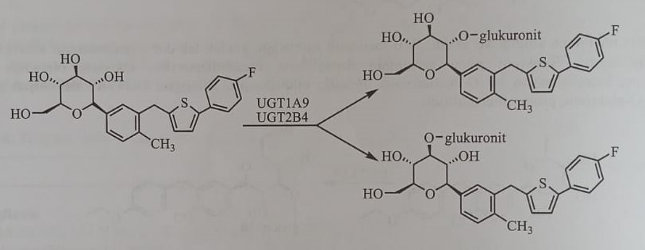
Empagliflozin is synthesized similarly to canagliflozin, using 5-bromo-2-chlorobenzoic acid and ethoxybenzene.
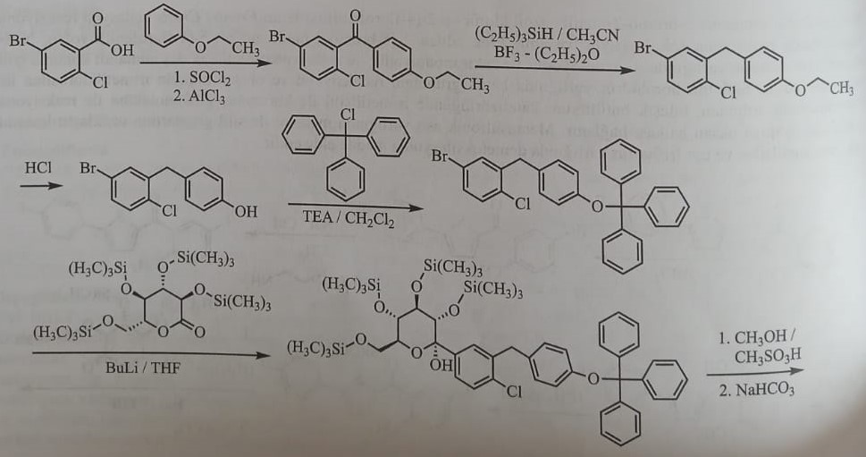
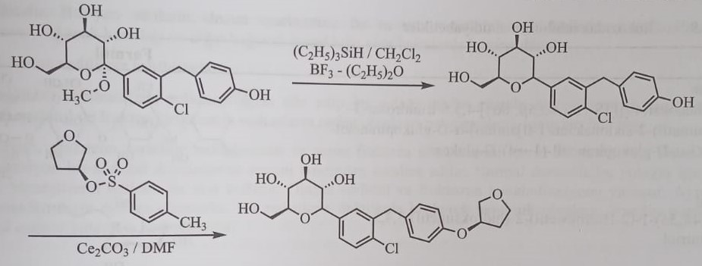
Empagliflozin is another selective inhibitor of SGLT-2, reaching the maximum concentration in plasma after 1.3-3 hours after oral administration and with a half-life of 10-19 hours. Depending on the dose, it reduces the level of sugar in the blood and increases the excretion of glucose in the urine.
The primary metabolites of empagliflozin are 2-O-, 3-O- and 6-O-glucuronides, formed as a result of glucuronidation by 5,-diphospho-glucronosyltransferases (UG2B7, UGT1A3, UGT1A8 and UGT1A9).
Enzyme inhibitors
In recent years, new methods of treatment of diabetes mellitus have been improved, it is not enough to simply reduce the level of sugar in the blood, the possibilities of prevention and elimination of pathological conditions caused by diabetes mellitus have been studied, and enzyme inhibitors have entered medical practice. . Although a small amount of drugs from this group are still included in treatment, research in this direction continues.
Some of the enzyme inhibitors used in the treatment of diabetes inhibit the enzyme aldose reductase (inhibitors of aldose reductase), and others inhibit the enzyme α-D-glucosidase (inhibitors of glucosidase).
Glucosidase inhibitor
α-glucosidase and α-amylase are enzymes involved in carbohydrate metabolism. Salivary and pancreatic amylase provide the conversion of polysaccharides into oligosaccharides and disaccharides and, thus, absorption from the intestines. The enzyme α-glucosidase, consisting of enzymes maltase, sucrase, isomaltase and glucoamylase, is found in high concentrations in the small intestine and catalyzes the splitting of disaccharides into glucose and other monosaccharides by breaking the 1,4-α-glycosidic bond in the small intestine. disaccharide sucrose and maltose. Processed monosaccharides are absorbed from the small intestine and enter the bloodstream.
Compounds that are inhibitors of α-glucosidase are mainly derivatives of sugars. Acarbose, an analog of an oligosaccharide, and miglitol, an analog of a monosaccharide, and emiglitad are more active in relation to this enzyme than the digested carbohydrate molecule. As a result, the digestion of carbohydrates in the intestines is delayed, and undigested carbohydrates are excreted from the body with feces, without being absorbed from the intestines.
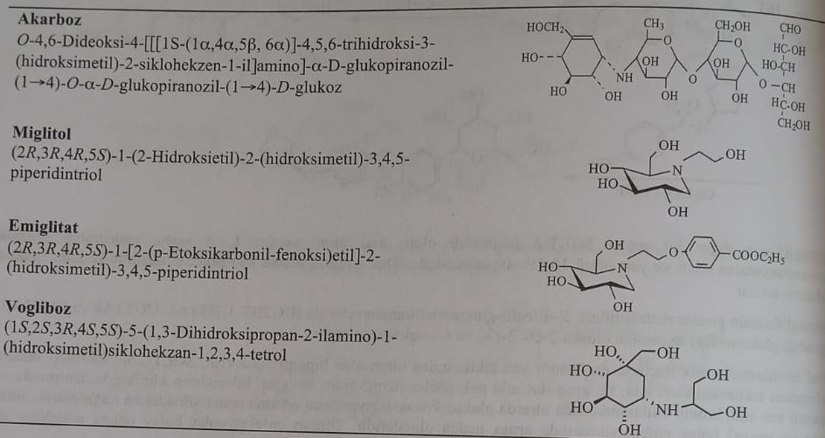
Acarbose, released on the market in 1996, is the first α-glucosidase inhibitor. The compound blocks weaker glucoamylase and pancreatic α-amylase. It has a high avidity mainly for the enzyme sucrase. Inhibiting α-amylase of the pancreas, it prevents the conversion of starch into oligosaccharides.
Miglitol and voglibose are other α-glucosidase inhibitors used in the clinic. Constant use of these compounds induces the secretion of GLP-1 and reduces the effect of DPP-4.
Acarbose in a pseudotetrasaccharide structure containing an unsaturated cyclite residue was isolated from actinoplanes. Miglitol and emiglitad were synthesized from 1-deoxynogyrimide ([2R-(2α,3β,4α,5β)]-2-(hydroxymethyl)-3,4,5-piperidintriol), isolated from the fruits of the mulberry tree or from the culture of Bacillus subtilis DSM 704 .done. For this reason, deoxynogirimycin reacts with β-chloroethanol or ethyl-4-(2-chloroethoxy)benzoatom.
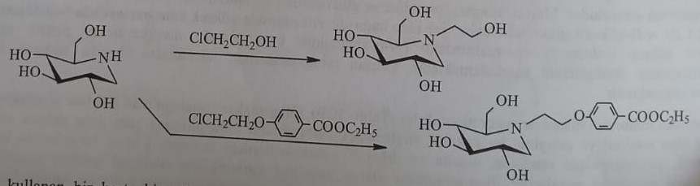
If hypoglycemia occurs in a patient using acarbose, glucose should be taken as an antidote.
Aldose reductase inhibitors
Aldose reductase inhibitors inhibit this pathway by interfering with the polyol reaction. As a result of hypoglycemia, sorbitol and fructose accumulate in some tissues.
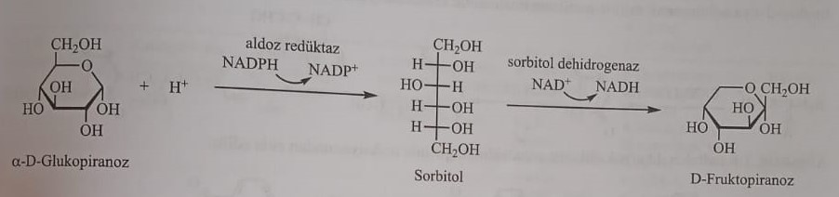
The polyol reaction catalyzes the reduction of glucose to sorbitol and then to fructose. The first reaction is catalyzed by aldose reductase, and the second reaction by sorbitol dehydrogenase. In normal conditions, this reaction does not go long, and in case of hyperglycemia, it increases. The active sorbitol and fructose slow down the metabolism. It accumulates in the tissues and causes pathological conditions, for example, fructose accumulates in the eye and causes cataracts.
Tolrestatin is the first aldose reductase inhibitor to enter the treatment. It is a long-acting compound. It is used in the treatment of diabetic nephropathy, retinopathy and cataract. Epelrestat is a second aldose reductase inhibitor. It is used in the treatment of diabetic neuropathy.
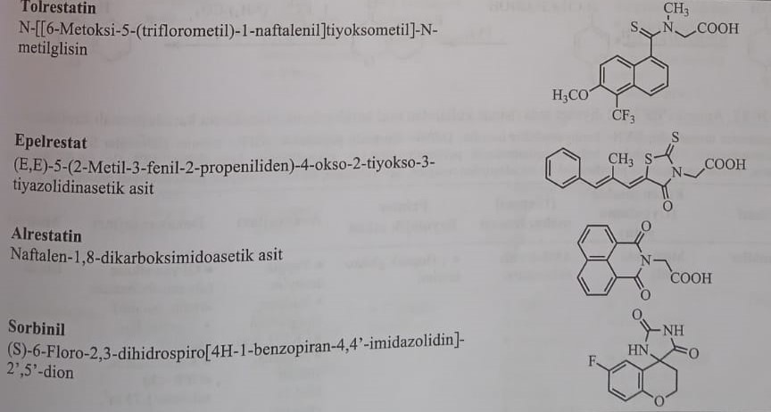
Tolrestatin is obtained by the reaction of 1-thiocarbamoyl-5-trifluoromethyl-6-methoxynaphthalene with N-methylamino acetic acid.
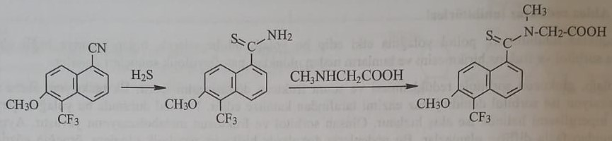
Epelrestat is obtained by condensation of rhodanine N-acetic acid (4-oxo-2-thioxo-3-thiazolidineacetic acid) with α-methylcinnamaldehyde, which is formed by the reaction of chloroacetic acid with ammonium dithiocarbamate.
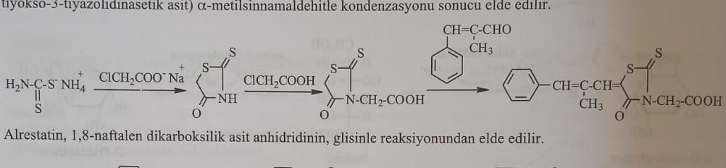
Alrestatin is obtained from the reaction of 1,8-naphthalene dicarboxylic acid anhydride with glycine.
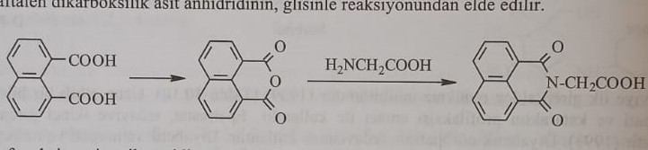
The effect of a mixture of potassium cyanide and ammonium carbonate on 6-fluorobenzopyran-4-one obtained as a result of cyclization of sorbinyl p-fluorophenoxypropionic acid with polyphosphoric acid (PFA) (hydantoin synthesis) is obtained. After the reaction is over, the S enantiomer is separated among the enantiomers.
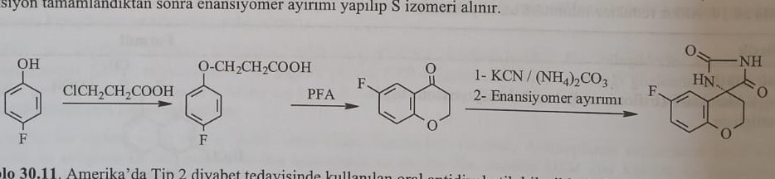
Comparative table of antidiabetic compounds
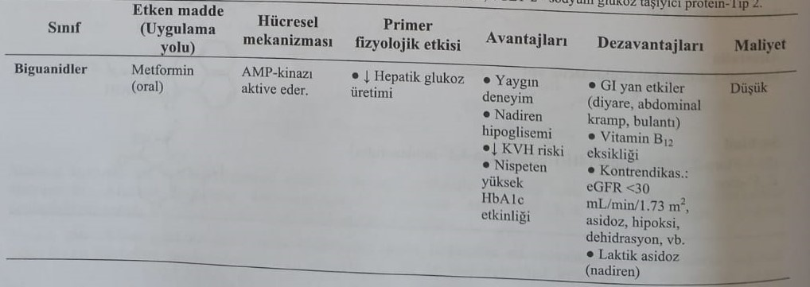
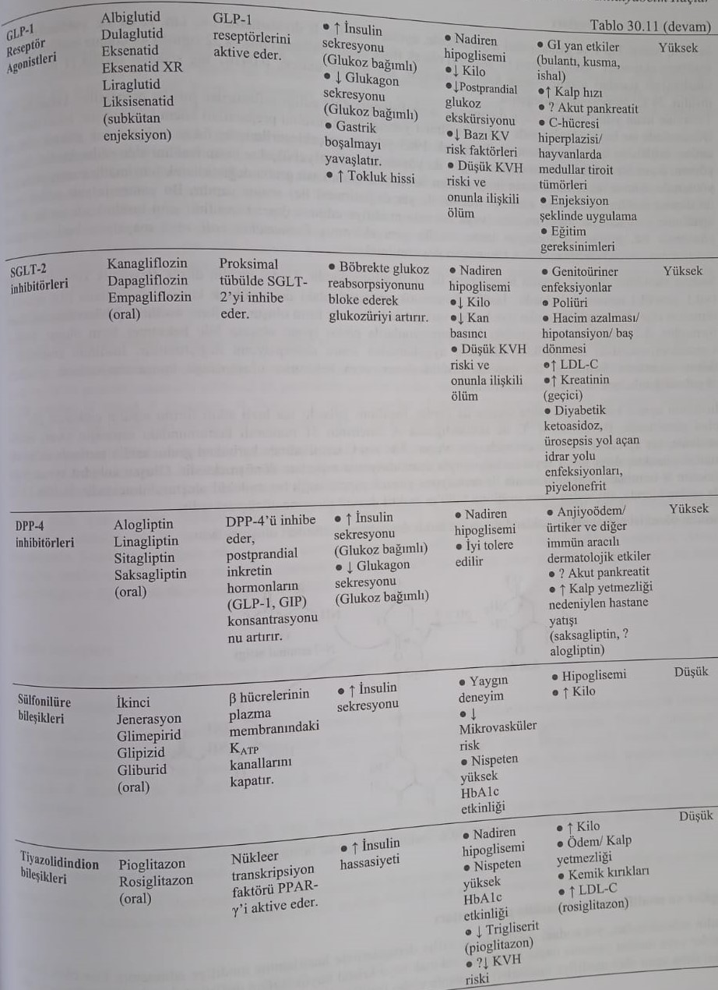
Insulin and analogues
Insulin is administered to patients with all types of diabetes 1 and gestational diabetes and even some types of diabetes 2 intravenously, intramuscularly, or subcutaneously. Insulin activity is expressed in units of insulin action. A mixture of purified 52% bovine and 48% porcine insulin is accepted as the international insulin standard. One unit of insulin action is equal to 0.04167 mg of standard insulin activity. 1 mg of standard insulin means 24 IU of insulin activity.
Insulin preparations extracted and purified from cattle or pigs have been used in treatment for many years. Currently, human insulin preparations are used instead of insulin obtained from animals. Human insulin was first synthesized from amino acids in 1963. However, this method, which is not very profitable from an economic point of view, has not received industrial significance. Currently, human insulin is produced in the industry in two ways. In the first method, human insulin is obtained by replacing amino acids in pig insulin, different from human insulin (replacing alanine B-30 in pig insulin with threonine by enzymatic transpeptidation). Human insulin obtained by this method is considered semi-synthetic human insulin. In the second method, human insulin is obtained with the use of Escherichia coli, to which the human insulin gene coding for proinsulin is added (recombinant DNA technology).
Only monomeric insulin can interact with insulin receptors. Natural insulin exists in monomeric form in low physiological concentrations (<0.1 μmol/l). In preparations, insulin dimerizes in large doses (0.6 mmol/l). At neutral pH, it forms a hexameric form in the presence of zinc ions, and this form is the reserve form of insulin in β-cells. Changes in the concentration of insulin can also change its absorption after subcutaneous administration. The absorptive form of insulin is a monomeric form. Therefore, insulin in dimeric or hexameric forms is very difficult to absorb when administered subcutaneously.
Insulin also has the problem of chemical instability. For many years, the only fast-acting form of insulin, insulin-zinc, was a solution with a pH of 2-3. When storing this solution at 4ºC, the amino acid asparagine (Asn) at position 21 of the A-chain is subjected to deamination of 1-2% per month. The carboxyl group at the C-end of Asn is cyclized to an anhydride in an acidic medium, which then reacts with water, undergoing deamination. The formed anhydride also reacts with phenylalanine at the N-end of the second chain with the formation of a cross-linked molecule.
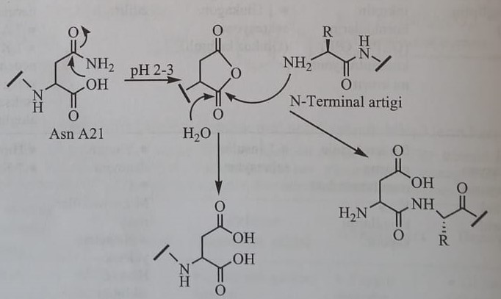
Common and modified insulin preparations
Insulin preparations contain unmodified short-acting insulin, prepared in the above images and degrees of purity. Preparations with a longer duration of action (protamine-zinc-insulin, globin-zinc-insulin and ribbon insulin), obtained by adding a second substance to the insulin structure or changing the size of the crystals, are called modified insulin preparations.
Ordinary insulin
Unmodified insulin is called regular insulin. This is short-acting insulin. When preparing the preparation, insulin is precipitated in the medium of zinc chloride, and in this way, crystalline ordinary insulin is obtained. Crystals are basically hexamers containing 6 insulin molecules. If precipitation is carried out by adding zinc chloride to the medium, amorphous ordinary insulin is formed. Currently, amorphous regular insulin is not used.
Ordinary insulin is a solution of crystalline zinc insulin. This is the only preparation of insulin in the form of a solution. Other insulin preparations are used in the form of suspension. Ordinary insulin has a short action and is the only insulin that can be administered intravenously. Regular insulin is also called soluble insulin. Ordinary solution of insulin for injections was pre-prepared in a phosphate buffer solution with pH=3. Since 1970, after the improvement of methods that allow cleaning insulin from product contamination, preparations of ordinary insulin began to be obtained, which do not precipitate in an environment with pH=7. It was found that this preparation, called neutral ordinary insulin, is more stable than insulin preparations in an acidic environment.
Modified insulin preparations
Modified insulin preparations are protamine-zinc-insulin and tape insulin. These are drugs of long or medium action.
Protamine-insulin-zinc is obtained by the interaction of insulin-zinc with protamine (a protein of simple structure obtained from trout sperm) in a phosphate-buffered solution, and its neutralization - isophane-insulin or NPH-insulin (N-neutral P-protamine H-Hagedorn ). (name of the researcher who improved the formula)) is obtained. When insulin is treated with globulin obtained from the blood of cattle, globulin-insulin-zinc is obtained.
When adding a solution of zinc chloride to a buffer solution of insulin acetate, depending on the concentration of zinc, insulin turns into an amorphous or crystalline form. Insulin preparations prepared by this method are called zinc insulin preparations or strip insulin.
Amorphous product is semi-delayed insulin (semilent), and crystalline insulin is called very slow insulin (ultra tape). A mixture of 30% semilent and 70% ultratape insulin is called slow insulin (tape). Semilent-insulin is similar to regular insulin, and ultralent-insulin is similar to NPH insulin.
An analog of insulin
Insulin analogues are grouped by the speed of onset of action and duration of action.
Analogy of short action
In the structure-activity relationship, it was found that by changing or removing amino acid residues at the C-end of the B-chain, the formation of a dimer, an inactive form of insulin, is prevented without changing the biological effect. Prevention of the formation of dimers leads to a rapid onset of action. Therefore, fast-acting analogs of insulin were obtained synthetically by recombinant DNA technology by making changes to the C-end of the B-chain or by adding new groups.
The first product in this group to receive FDA approval is insulin lispro. The amino acid composition of insulin lispro is identical to human insulin. Only proline in position 28 of the B-chain is replaced by lysine in position 29 of this insulin analog.
Insulin aspart is obtained by replacing proline at position 28 of the B-chain of insulin with aspartic acid. After subcutaneous administration, insulin aspart quickly dissociates into dimers and monomers.
Insulin glulisine is obtained by replacing arginine in position 3 with lysine and lysine in position 29 with glutamic acid in chain B. The effects of lispro, asparta and glulisine begin after 15 minutes, reach a maximum after 30-90 minutes and last for 3-4 hours.
Analogy of long-acting action
Insulin glargine is the first analogue of long-acting human insulin. It is obtained by replacing asparagine in position 21 of the A-chain of insulin with glycine and adding two arginines to the C-end of the B-chain. Insulin glargine dissolves in a slightly acidic medium. It is in the form of a hexamer. This form dissolves slowly and has a long-lasting effect.
Insulin detemir is obtained by joining the fatty acid myristic acid with the amino acid lysine at position 29 of the B-chain of insulin and removing threonine at position 30 from the molecule. Thanks to myristic acid, the skin binds to albumin in the tissues and later turns into a monomer.
Insulin Degludec is the newest alkylated analogue of insulin of the second generation of super-long action. It was registered in Japan, Europe, Mexico and 60 countries. It was obtained by removing threonine in the 30th position of insulin and combining the gamma-L-glutamyl intermediate chain of the amino acid lysine in the 29th position in the B-chain with hexadecanedioic acid. When the compound is administered subcutaneously, a solubilized hexamer is formed, from which monomers are slowly released, which simultaneously have a combined depot effect on albumin plasma. The duration of the effect is 42 hours.
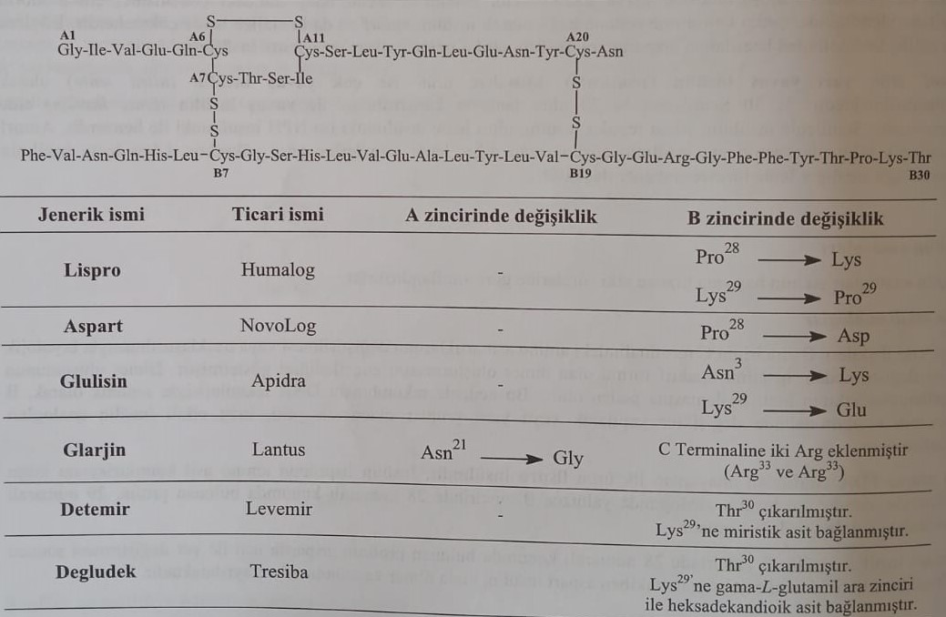
Insulin types and duration of action
